# Project Design Phase-I Solution Architecture

|  |  |
| --- | --- |
| Date | 31/12/2023 |
| Team ID | 591966 |
| Project Name | MOVIE RECOMMENDATION SYSTEM |
| Maximum Marks | 4 Marks |

**Solution Architecture:**

Architecture Components:

User Interface (UI):

Description: The UI component represents the front-end of the application, including web and mobile interfaces. It is responsible for presenting movie recommendations to users, displaying user profiles, and facilitating interactions.

Behavior: The UI interacts with the backend services to request and display personalized recommendations, user profiles, and other relevant information. It also collects user feedback and preferences.

Frontend Logic:

Description: This component comprises the logic responsible for rendering UI elements and handling user interactions on the client side. It may include frameworks like React, Angular, or Vue.js.

Behavior: The frontend logic communicates with the backend through APIs to retrieve and display recommended movies, user profiles, and other relevant data. It also handles user input and updates the UI accordingly.

Recommendation Engine:

Description: The recommendation engine is the core of the system, responsible for generating personalized movie recommendations for users. It incorporates machine learning algorithms, collaborative filtering, content-based filtering, and emotion analysis.

Behavior: The recommendation engine analyzes user behavior, preferences, and contextual information to generate movie recommendations. It continuously learns and adapts based on user feedback and changing preferences.

User Profile Management:

Description: This component manages user profiles, storing information about user preferences, viewing history, and demographic data.

Behavior: It captures and updates user data, ensuring that the recommendation engine has accurate and up-to-date information to generate personalized suggestions.

Content Management:

Description: The content management component handles the ingestion, storage, and retrieval of movie data. It includes metadata such as genres, ratings, cast, and reviews.

Behavior: This component ensures that the system has a comprehensive and up-to-date library of movies. It integrates with external sources or databases to fetch movie-related information.

Authentication and Authorization:

Description: This component manages user authentication and authorization, ensuring secure access to user accounts and data.

Behavior: It handles user login/logout, verifies user identity, and enforces access control to protect sensitive user information.

Feedback and Rating System:

Description: The feedback and rating system allows users to provide feedback on recommended movies and rate their viewing experience.

Behavior: It collects user ratings, reviews, and feedback, which are used to refine the recommendation algorithms and improve the accuracy of future suggestions.

Notification Service:

Description: The notification service sends alerts and updates to users, such as new movie recommendations, personalized announcements, or system updates.

Behavior: It communicates with the recommendation engine to trigger notifications based on user preferences and system events.

Analytics and Monitoring:

Description: The analytics and monitoring component tracks system performance, user engagement, and other key metrics.

Behavior: It generates reports, logs, and alerts based on the analysis of system data. This information is valuable for optimizing system performance and identifying areas for improvement.

Interaction Flow:

User Registration and Authentication:

Users register or log in to the system, providing authentication credentials.

Profile Creation:

Users create profiles, specifying preferences, genres of interest, and any additional information that can enhance recommendations.

Movie Recommendations:

The recommendation engine analyzes user profiles and behavior to generate personalized movie recommendations.

User Interaction:

Users interact with the UI to view recommended movies, provide feedback, and explore additional features.

Feedback Loop:

User feedback, ratings, and interactions are collected and fed back into the recommendation engine to continually improve the accuracy of future recommendations.

Content Management:

The system updates its movie database with new releases, ratings, and metadata to ensure a comprehensive and current content library.

Notification and Alerts:

Users receive notifications for new recommendations, updates, or personalized announcements based on their preferences.

Other Aspects:

Scalability: The architecture is designed to scale horizontally to handle increased user loads and growing data volumes. This involves load balancing, microservices, and the use of scalable infrastructure.

Security: Security measures, including encryption, secure connections, and proper authentication mechanisms, are implemented to protect user data and ensure a secure user experience.

Privacy: Privacy-preserving techniques, such as federated learning and anonymization, are employed to safeguard user data and comply with privacy regulations.

Performance Optimization: Caching, asynchronous processing, and other performance optimization techniques are implemented to ensure a responsive and efficient user experience.

Technologies Used: The choice of technologies may include programming languages (e.g., Python, Java), frameworks (e.g., Django, Flask), databases (e.g., MongoDB, MySQL), and machine learning libraries (e.g., TensorFlow, PyTorch).

The proposed architecture is designed to create a seamless and enjoyable movie-watching experience, with a focus on personalization, scalability, security, and continuous improvement based on user feedback and preferences

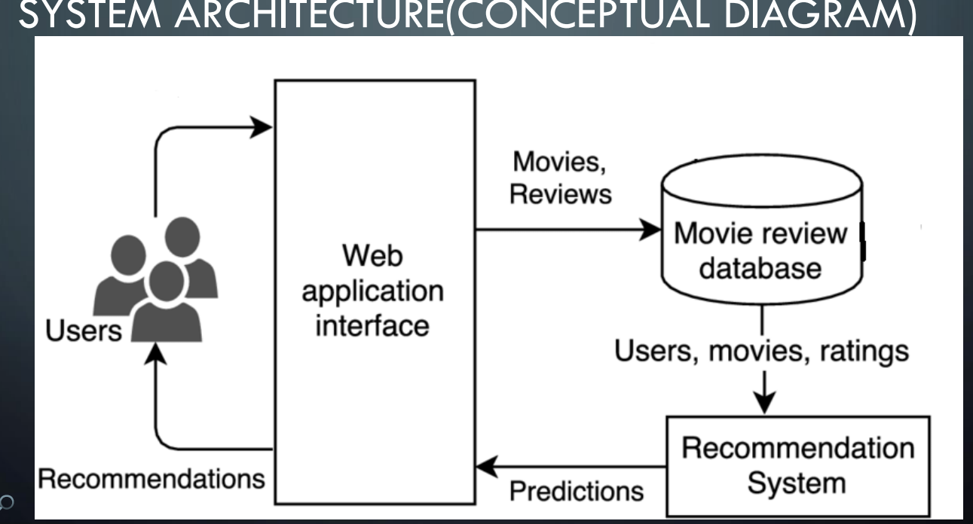

*Figure 1: Architecture and data flow of the application*

